

It 20.2

By Adam Chu



Contents

Scripting Languages 1

How is JavaScript Commonly used in Web Pages 1

How have I used JavaScript 1

How else can JavaScript be used add functionality to the web 1

Testing 1

What does my website look like in different browsers 2

Edge 2

Edge Mobile Version 2

Chrome 3

Chrome Mobile 3

Evaluation 3

Examples of Good Code Design 3

Evaluation of my Web Pages 4

# Scripting Languages

Scripting languages are used by programmers that are interpreted from a source code and translated line by line which is why compiled programs run in their entirety faster than the scripting languages as all of the code is translated (compiled) into machine code. For example using a C program needs compiling compared to Python where the code is interpreted.

Compiled code collects a list of errors in the codes entirety after running the code, whereas scripting languages stop when they hit an error and halt the code.

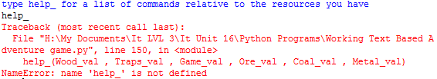

## How is JavaScript Commonly used in Web Pages

JavaScript is usually added to webpages to add interactivity and this is done by controlling elements like buttons which then do calculations. It also can change CSS but I have not done this as it would be quicker in this instance to use inline CSS. This also allows you to edit the html of an item that you have already tagged with an id.

## How have I used JavaScript

I used JS to do the calculations by defining the each of the 7 buttons with an id from but0 to but6, and also got the JS to set when a title button is clicked the inner HTML (the labels) changes and when the named black button is clicked, the code checks the name of the button clicked and then runs the calculates the values and outputs them to each of the boxes. This also allows one webpage to do multiple calculations so that you don’t need more pages you can use 1.

## How else can JavaScript be used add functionality to the web

JavaScript can change the inner tags to HTML for example on W3 Schools they have a button which changes the src of an img tag. JS can directly impact HTML and CSS used on the webpage. You can have some animations that attract attention to parts of page.

In my website I should have made the active class buttons coloured in a different way, this would make it easier to know which unit you have selected or I could have made it so that the input box adds a unit after the calculation has finished.

# Testing

|  |  |  |  |  |
| --- | --- | --- | --- | --- |
| Number | What is being tested? | Expected Result | Actual Result | Passed/Failed |
| 1 | What happens when a button is pressed | Labelled buttons will change / or perform a calculation | True | Passed |
| 2 | Does the page auto update when a button is pressed | It should update when a new button is pressed | No it does not auto update as the code needs 2 criteria to work | Failed |
| 3 | Does the text highlight properly | Yes it highlights green | True | True |
| 4 | Does it fail when a NaN is used | Yes it prints the NaN and the Units | True | True |
| 5 | Is the content adjusted with View size | Yes it uses vw / vh | True | True |
| 6 | Are the boxes differentiated | They should be different colours | True they are a gradient and black | Passed |
| 7 | Does the gradient stand out | Yes according to a 3rd party | Dodger-blue then royal blue then dark blue (top left to BR) | Passed |
| 8 | Does the selected class change in a noticeable way | The text should change and the button could change colour | The text in the black boxes should change colour but the class does not change colour | Passed |

# What does my website look like in different browsers

## Edge

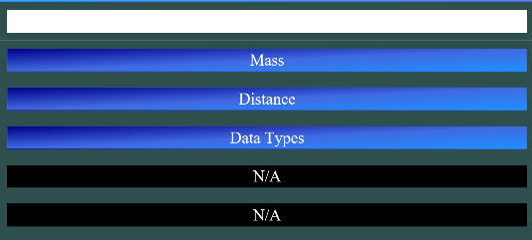This looks as intended as the browser has set the area around at 95vw, this shows the gradient and website works as intended.

## Edge Mobile Version

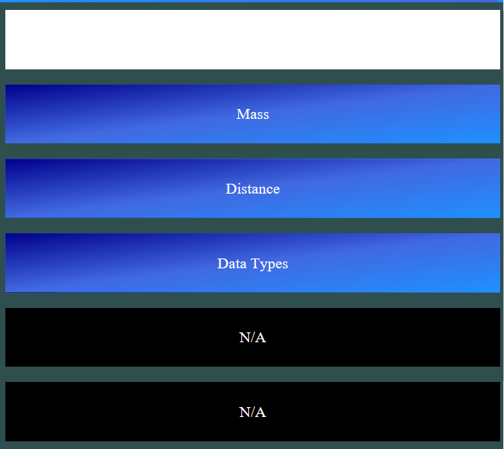This works as intended as the boxes and the font change with the size of the browser, this is fine and when you use the text box an on-screen keyboard appears.

## Chrome

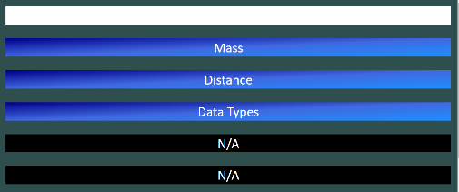On chrome the website runs fine but the font David was not installed on the version of chrome I was using meaning it chose a default font.

## Chrome Mobile

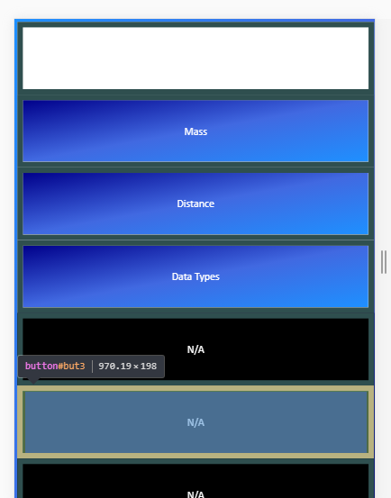The chrome mobile looks the best in mobile mode, but the font seems to not scale properly as well as the font is extremely small. As well as not using the correct font that I selected via CSS.

# Evaluation

## Examples of Good Code Design

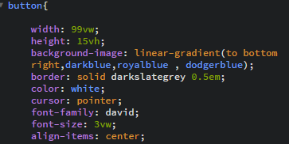

Using VW & VH means that the website resizes itself when the display changes resolution doing this to all items in the HTML document means it always is in proportions.

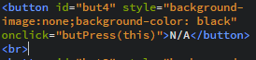

What this is doing is it takes the bottom buttons which are not initially labelled, and it removes the original gradient applied by the external CSS and replaces it with a black font. I could have made a new class called like button2 but I thought this would be quicker than having to worry if it interferes with the JS.

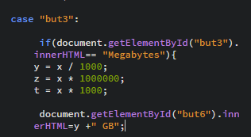

By having an if statement check the inner html of a button allowed me to easily map many different functions to a button this used an if statement compared all options for the button then checking it against the already assigned labelled.

## Evaluation of my Web Pages

|  |  |  |
| --- | --- | --- |
| Pro / Con | What is Wrong / Right | How it could be improved |
| Pro | The fact that all of the calculations occur on one page instead of multiple.  This could have been done nicer for desktops with dropdowns but I wanted it for mobile so I used reactive buttons. | It could have many more calculations using a new buttons:   1. Increase the number of units per class 2. Increase the number of classes |
| Pro | The colour scheme followed the swatches that I laid out in the design document  (means the saturation is similar or the same) | I did not use all of the colours like medium orchid when I wanted to. But I really liked the gradient from dodger blue to dark blue. |
| Pro | The website is capable of doing more calculations than was requested at 12 in total | The code is convoluted with if statements inside case statements, and add more options like the first pro. |
| Pro | The code is designed to be extended using procedural programming | The code is procedural so you can add new buttons with different id’s and add them to the function. |
| Con | The code requires the user to select a class every time you want a conversion, even if its in the same class. | I could make the inner html of the class an event handler so when the unit is pressed it checks the class. |
| Con | There is no clear indication that the button has been selected I think this is important in the next update. | This is simple to do using CSS and a button:clicked tag and changing the colour, or using JavaScript at the start of each function changing the colour of the item but this would be overwritten by the inline CSS |
| Con | The program is not super intuitive with having to input a number before selecting a class in the website | I should set the code to loop and allow the class to be selected and run the code when InputVal =! Null, this would allow the code to run after being selected  This would increase useablity when I got a 3rd party to test it they got really confused by this flaw in the code. |
| Con | I should make the text box show a string like input number here this should clear when the user clicks on the box | This would either use a while loop when InputVal =! Null or using an if statement that says when InputVal.clicked then change the inner.html to “” from “Input a Number into this textbox” |
| Con | It should have an error message when x is NaN | This could be done during the calculating period where the numbers get processed this could be another if statement where if y + z + t (+ = or) == “NaN” using window.popup commands. |